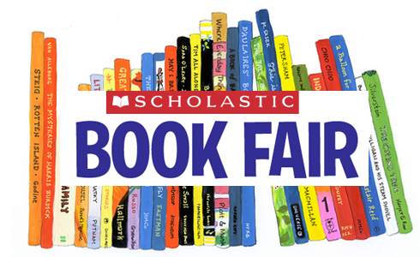
This year’s Book Fair will be held, November 18 – 22. Students will have an opportunity to preview the fair on Monday with their class, and the Book Fair will then be “open for business” after all classes have looked through.
Book Fair hours are:
Monday 1:45 – 4:00
Tuesday 7:45 – 3:00
Wednesday 7:45 – 3:00
Thursday 7:45 – 4:00
Friday 7:45 - 3:00

This is a great opportunity to stock up on books, buy Christmas presents and peruse some of the new titles available. It also is a fantastic fundraiser for our library, as we are given a percentage of sales to purchase books for our school collection. A board of “wish lists” from classroom teachers will also be displayed outside the fair if you wish to purchase a book for your child’s classroom. Thank you so much for your kind support with this!!

Also, parents who are willing and able to help sell at the book fair are encouraged to sign up on the volunteer sheet located in the school foyer outside the library.
Happy reading!!

